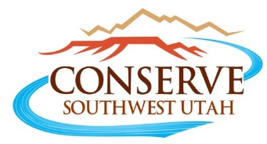
6-19-19

The Campaign to Continue the Existing
Red Cliffs Habitat Conservation Plan & National Conservation Area

Rejecting Washington County’s Northern Corridor Proposal

The Coalition to Preserve the Red Cliffs National Conservation Area

Advocates for the West
Backcountry Horsemen of America
Center for Biodiversity
Conservation Lands Foundation
Conserve Southwest Utah
Desert Tortoise Council
Great Old Broads for the Wilderness
Southern Utah Wilderness Alliance
Sierra Club, Sierra Club - Utah Chapter
The Wilderness Society
Western Watersheds Project
WildEarth Guardians

