Federal regulators hit pause on Lake Powell Pipeline, at

Utah’s request
David DeMille, The Spectrum Published 10:16 a.m. MT Jan. 13, 2018
Buy Photo
(Photo: Brian Passey / The Spectrum & Daily News)
CONNECTTWEETLINKEDINCOMMENTEMAILMORE
At Utah’s request, federal regulators are halting their review of the proposed Lake Powell Pipeline to address jurisdictional questions that state leaders say have left them confused over which federal agency, or agencies, need to approve certain parts of the project.
The Federal Energy Regulatory Commission agreed this week to put its review of the project on hold, but did not immediately address the state’s questions regarding jurisdiction.
State water officials have spent more than $30 million over the past decade readying its proposals for the pipeline, which would carry water some 140 miles out of Lake Powell and across parts of Utah and Arizona to thirsty communities in Washington and Kane counties.
Related coverage:
Lake Powell Pipeline approved for environmental analysis
How much will the Lake Powell Pipeline cost? It's still being studied
Impact fee increases proposed to fund Lake Powell Pipeline, other projects
‘Financing model’ released for Lake Powell Pipeline
State officials applied for the project through FERC because of proposed hydroelectric facilities that would be built along the pipeline. The water would be pumped out of Lake Powell to a high point within the boundaries of the Grand Staircase-Escalante National Monument, then flow downhill toward St. George, passing through a series of hydroelectric turbines along the way. There are currently six different hydroelectric facilities proposed, along with related transmission lines.
But when FERC announced in December that it would move forward with an environmental analysis for the project, the agency also suggested it might decide only to approve the power facilities themselves and not the “penstock” pipelines that feed them, meaning the state could need to go through new permitting processes, either for 50 miles of pipelines that cross federal lands managed by the Bureau of Land Management or for an alternative route that crosses 17 miles through the Kaibab Paiute Tribe reservation and would require permitting through the Bureau of Indian Affairs.
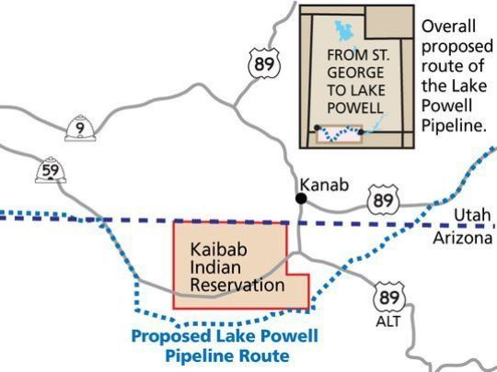Buy Photo
The route of the Lake Powell Pipeline is still uncertain, with Utah officials proposing the project go around the Kaibab Paiute Tribe reservation but tribal leaders asking to be included in the project. (Photo: The Spectrum & Daily News)
In response, attorneys for the state and the Washington County Water Conservancy District sent a letter to the agency requesting it clarify that FERC has sole jurisdiction, citing past examples of water projects handled by the agency. It also asked the agency to halt the already-underway permitting process to reset any application deadlines.
“The sooner the Commission resolves this issue, the sooner the application for this major new infrastructure project benefitting the citizens of southwestern Utah can move forward,” according to the letter.
State and local water managers said jurisdictional clarity is necessary before moving forward, even if it delays what they argue is a tight timeline before the fast-growing St. George area needs the water.
Ron Thompson, general manager of the WCWCD, said the goal has been to have the pipeline approved, built and operational by the end of the 2020s in order to keep ahead of district forecasts for population growth and increased demand.
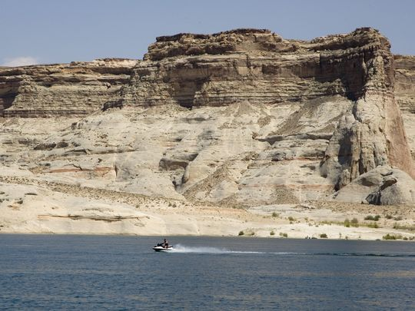Buy Photo
A water craft jets past Warm Creek Bay at Lake Powell in the Spectrum file photo. (Photo: Jud Burkett / The Spectrum)
“If I have a worry personally, it’s that we would like to keep a 10 to 15 year buffer in front of us. We do not have that buffer today,” he said.
The pipeline has been the target of controversy for years, one of a series of projects state’s have proposed to pull more water from the Colorado River system despite evidence that the river’s supplies are already overdrawn and that climate change is likely to dry the region further in the future.
Local opponents of the pipeline contend the relatively small communities of Washington and Kane counties aren’t equipped to fund such a large project, arguing taxpayers across the rest of the state would need to cover much of the cost.
In the original licensing proposal, state managers estimate the cost at between $1.4 billion and $1.8 billion, but representatives at both the local water districts and the state office have maintained for years that the price tag could vary widely based on a slew of variables, such as whether the pipeline could cross the the Kaibab reservation or go around, and whether the electricity market warrants construction of hydroelectric stations along the way.
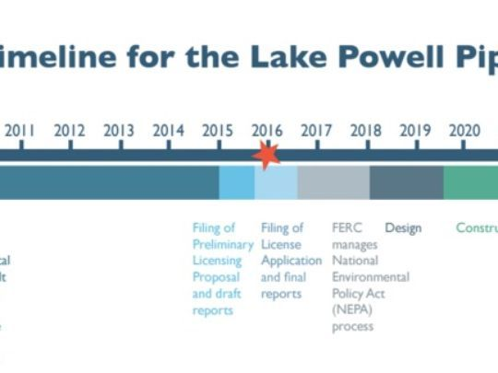
(Photo: Washington County Water Conservancy District)
No official repayment plan has been published that describes how the individual water districts and the state would cover the costs, and state lawmakers have passed legislation requiring that they approve a financing plan before construction begins.
Economists with several Utah universities have signed on to work done over the last three years, primarily by Gabriel Lozada and Gail Blattenberger from the University of Utah, arguing against the economic viability of the project. Last year they released an analysis of a preliminary financial model acquired from Washington County, arguing the numbers showed the districts would need the rest of the state to subsidize about 70 percent of the actual costs of the pipeline.
Follow David DeMille on Twitter, @SpectrumDeMille, and on Facebook at www.facebook.com/SpectrumDeMille. Call him at 435-674-6261.
CONNECTTWEETLINKEDINCOMMENTEMAILMORE

