Re
October 23, 2020

To: Greg Sheehan Keith Rigtrup
Utah State Director, BLM St. George Field Office Manager, BLM
440 W 200 S #500 345 East Riverside Drive
Salt Lake City, UT 84101 St. George, UT 84790
gsheehan@blm.gov krigtrup@blm.gov

Cc: BLM and FWS management
Washington County HCP and transportation governance and staff (HCAC, DTEC, DTAC)

Re: Red Cliffs Coalition Issues with the Inclusion and Consideration of Cost Estimates in the Northern Corridor Final Environmental Impact Statement, 2800 (UTC0300), UTU-93620

Dear Mr. Sheehan and Mr. Rigtrup,

We, the undersigned, have become aware that BLM is preparing cost estimates for each of the alternatives for the Northern Corridor Highway addressed in the Draft Environmental Impact Statement (DEIS), and will be including and considering them in the Final Environmental Impact Statement (FEIS). While we support the concept of using cost estimates in the evaluation of the alternatives, BLM must prepare a full and comprehensive cost-benefit analysis in order to adequately evaluate each alternative. It is equally imperative that BLM consider all costs of an alternative, both economic and non-economic costs, and not arbitrarily limit the analysis to only the cost of construction and related property impacts. Moreover, BLM must provide public notice and comment on any cost-benefit analysis, and BLM must refrain from including a cost estimate for the first time in its FEIS.
Including a partial cost estimate, without appropriate public comment and active engagement of stakeholders in the development and analysis of variations in the designs, especially for alternatives outside the NCA, would render any analysis arbitrary and capricious. We request the development of a Supplemental DEIS for the following reasons:

- Allowing Public Comment
Foreclosing and otherwise prohibiting public notice and comment on a cost-benefit analysis or cost estimate will run afoul of BLM’s obligations under the National Environmental Policy Act, 42 U.S.C §§ 4321 et seq. and the Federal Land Policy and Management Act, 43 U.S.C. §§ 1701 et seq. Indeed, it appears BLM has abandoned its prior conclusion that a “cost-benefit analysis is not necessary to make a reasoned choice between alternatives since there are important qualitative considerations that are described in the Draft EIS.” This change of position is significant, warrants further explanation and discussion, and BLM must permit public notice and comment on this shift, as well as the underlying analyses.

- Addressing Design Variations
As described in our DEIS comments, BLM inadequately defines and analyzes DEIS Alternatives 5 and 6, and any effort to prepare a cost estimate – or cost-benefit analysis – based on this inappropriate definition of Alternatives 5 and 6 would be arbitrary and capricious. More specifically, unlike Alternatives 2-4, which are defined in significant detail in the DEIS, Alternatives 5 and 6 are complex with significant variations possible in their detail designs, and the DEIS fails to undertake any serious analysis or effort at examining the scope of variations of each alternative, which will impact and inform the appropriate cost estimate. Fully explicating these alternatives and their variations, and the costs and benefits associated with them, must include full and robust public engagements.

Based on these issues, we dispute the validity of the property impacts and related costs for these alternatives as identified in the DEIS. The DEIS did not describe the precise location, nature or rationale for these impacts, making it extremely difficult for the public to verify or dispute them. Please see the attachment for a description of the issues and the rationale for re-evaluating DEIS Alternative 5’s projected property impacts. In an open and transparent engineering process, a design review would be convened with stakeholders to reveal, discuss and resolve these issues. A valid cost estimate is not possible without addressing these variations and issues in such a review.

- Considering All Costs and Benefits
A partial cost estimate limited to direct economic costs related to construction, as we understand as the scope of the information to be added in the FEIS, would present an invalid economic comparison. An economic impact comparison of alternatives should be based on a full cost-benefit analysis, including DEIS Alternatives 2-4 tourism/recreation business costs due to degradation of the NCA, ecosystem services costs, DEIS Alternative 6 business benefits due to enhancement of downtown shopping experience, the varying impacts of each alternative to the area’s image (environmental destroyer vs. protector), each alternative’s varying costs and benefits of traffic relief, and each alternative’s varying cost/benefits of cascading traffic impacts.

As previously noted, NEPA requires BLM to prepare a Supplemental DEIS to address the 2020 NCA wildfires’ impacts on existing conditions. BLM may include the updated alternatives design and analysis, including a proper cost/benefit analysis, in this same Supplemental DEIS. We are still awaiting BLM’s respond to our earlier request for a Supplemental DEIS. Please advise when and whether BLM intends to respond to that request.

Thank you for your consideration of this issue in a timely manner, prior to issuance of the FEIS.

Tom Butine
Board President, Conserve Southwest Utah
Coordinator, Red Cliffs Conservation Coalition
321 N Mall Dr., Ste B202, St George, UT, 84790
425.893.9781, tom@conservewswu.org
Red Cliffs Coalition Member Organizations
In alphabetical order

Advocates for the West
Basin and Range Watch
Back Country Horsemen of America - Utah
Center for Biological Diversity
Conservation Lands Foundation
Conserve Southwest Utah
Defenders of Wildlife
Desert Tortoise Council
Friends of the Inyo
Friends of Animals
Great Old Broads for Wilderness - Utah
Sierra Club - Utah
Southern Utah Wilderness Alliance
The Wilderness Society
Utah Audubon Council
Utah Native Plant Society
Western Watersheds Project
WildEarth Guardians

Cc:
Agency management
Christopher Keleher Species Recovery Prm Dir UDWR christopherkeleher@utah.gov
Dawna Ferris-Rowley Red Cliffs NCA Manager d8ferris@blm.gov
Callie Goff Planning & Env Coordinator lgoff@blm.gov
Loretta Markham Project Manager, Jacobs Engineering Loretta.Markham@jacobs.com
Ahmed Mohsen Color Country District Manager amohsen@blm.gov
Cameron Rognan Washington County HCP Admin cameron.rognan@washco.utah.gov
Laura Romin Deputy Field Supervisor, USFWS laura_romin@fws.gov
Noreen Walsh Region 6 Director, USFWS Noreen_Walsh@fws.gov
Gloria Tibbetts BLM_UT_NorthernCorridor@blm.gov
Yvete Converse yvette_converse@fws.gov

State and County HCP and transportation management, staff, advisors, consultants
HCAC
Chris Blake ccblake@live.com
John Bramall johnbramall@gmail.com
Chris Keleher christopherkeleher@utah.gov
Laura Romin
Dawna Ferris-Rowley
Gregg McArthur gregg.mcarthur@sgcity.org
Chris Hart chart@ivins.com
DTEC
Dean Cox, Washington County Commissioner, dean.cox@washco.utah.gov
Rick Rosenberg, Mayor, Santa Clara City, rick@racivil.com
Jimmie Hughes, St. George City Council Member, jimmie.hughes@sgcity.org
Ken Neilson, Washington City Mayor, kneilson@washingtoncity.org
Jon Pike, Mayor, City of St. George, jon.pike@sgcity.org
Chris Hart, Mayor, Ivins City, chrisghart@gmail.com
Naghi Zeenati, State of Utah Transportation Commissioner, naghi@realtyexpress.net
Michele Randall, St. George City Council Member, michele.randall@sgcity.org
John Bramall, Mayor, City of Hurricane, jbramall@cityofhurricane.com
Richard Hirschi, Mayor, LaVerkin, rmhirschi@gmail.com
Wayne Peterson, Mayor, Leeds, mayor@leedstown.org
Lynn Chamberlain, Mayor, Toquerville, mayorlynn@toquerville.org
Affiliated Agency Representatives
Rick Torgerson Director, Region 4, Utah Department of Transportation
Steven Call, FHWA, steven.call@fhwa.dot.gov
Myron Lee, DMPO director, mlee@fivecounty.utah.gov
DTAC
Chuck Gillette (Chair), Public Works Director, Ivins City, cgillette@ivins.com
Jack Taylor, Public Works Director, Santa Clara, jtaylor@sccity.org
Cameron Cutler, Public Works Director, St. George City, cameron.cutler@sgcity.org
Mike Shaw, Public Works Director, Washington City, mshaw@washingtoncity.org
Jay Sandberg, City Engineer, St. George City, jay.sandberg@sgcity.org
Monty Thurber, Engineering Associate, St. George City, monty.thurber@sgcity.org
Kayde Roberts, Program Manager UDOT, kayderob@utah.gov
Todd Edwards (Vice Chair), Public Works, Washington County, todd.edwards@washco.utah.gov
Arthur LeBaron, Public Works Director, Hurricane City, arthur@cityofhurricane.com
Wayne Peterson, Mayor, Leeds, mayor@leedstown.org
Kyle Gubler, LaVerkin City, Kyle.gubler@laverkincity.org
Ty Bringhurst, City Council, Toquerville City, tbringhurst79@gmail.com
Affiliated Agency Representatives (Non-Voting)
Kelly Lund, Fed. Highway Administration, kelly.lund@fhwa.dot.gov
Cameron Cutler, Acting Public Transit Director, St. George City, cameron.cutler@sgcity.org
Elden Bingham, Congestion Management Engineer UDOT, eldenbingham@utah.gov

Eric Clarke Washington County Attorney Eric.Clarke@wcattorney.com
Amanda Aurora Project Manager, SWCA aaurora@swca.com

christopherkeleher@utah.gov, d8ferris@blm.gov, lgoff@blm.gov, Loretta.Markham@jacobs.com, amohsen@blm.gov, cameron.rognan@washco.utah.gov, laura_romin@fws.gov, Noreen_Walsh@fws.gov, BLM_UT_NorthernCorridor@blm.gov, yvette_converse@fws.gov, ccblake@live.com, johnbramall@gmail.com, christopherkeleher@utah.gov, gregg.mcarthur@sgcity.org, chart@ivins.com, dean.cox@washco.utah.gov, rick@racivil.com, jimmie.hughes@sgcity.org, kneilson@washingtoncity.org, jon.pike@sgcity.org, chrisghart@gmail.com, naghi@realtyexpress.net, michele.randall@sgcity.org, rmhirschi@gmail.com, mayor@leedstown.org, mayorlynn@toquerville.org, steven.call@fhwa.dot.gov, mlee@fivecounty.utah.gov, cgillette@ivins.com, jtaylor@sccity.org, cameron.cutler@sgcity.org, mshaw@washingtoncity.org, jay.sandberg@sgcity.org, monty.thurber@sgcity.org, kayderob@utah.gov, todd.edwards@washco.utah.gov, arthur@cityofhurricane.com, mayor@leedstown.org, Kyle.gubler@laverkincity.org, tbringhurst79@gmail.com, kelly.lund@fhwa.dot.gov, cameron.cutler@sgcity.org, eldenbingham@utah.gov, Eric.Clarke@wcattorney.com , aaurora@swca.com

Attachment to letter dated October 23, 2020, Red Cliffs Coalition Issues
with the Inclusion and Consideration of Cost Estimates in the Northern Corridor Final Environmental Impact Statement (2800 (UTC0300), UTU-93620):
Alternative 5 Variations to be Considered in Cost Estimates

Contents
1 Background 6
2 Differences between DEIS Alternative 5 and CSU Alternatives 1 and 2 6
3 Issues with DEIS Alternative 5 7
4 Cascading Effects 8
5 Conclusion 8
6 Reference: DEIS description of 4.8 Red Hills Parkway Expressway 9
7 Relevant Corrections to Typographical Errors in our DEIS Comments 9
8 Figures and Tables 10

Background
The purpose and need addressed by the DEIS specifies the “objective of reducing congestion, increasing capacity, and improving east-west mobility on arterial and interstate roadways between State Route 18 (SR 18) and Interstate 15 (I-15) at milepost 13.” DEIS Alternatives 2-4 address this objective by effectively bypassing existing roads between the two end points. Considering only impacts on traffic (i.e., excluding environmental and non-traffic socio-economic impacts), these alternatives would have a direct impact on thru traffic, and an indirect impact on traffic within Washington City and St. George by removing that thru traffic from existing roads.

DEIS Alternative 5 is presented as if it was an equivalent solution to Alternatives 2-4, but it is not. It has the same direct and indirect effects as DEIS Alternatives 2-4, but has an additional direct positive impact on St. George traffic by adding efficiency to Red Hills Parkway (RHPW) at 200E and 1000E, and these efficiencies have a direct negative impact by closing or limiting access to RHPW from other roads. This makes neither the costs nor the benefits of DEIS Alternatives 2-4 and 5 comparable. In order to make them comparable, the DEIS should use CSU Alternative 1 (the flyovers, either option; see Figures 5 and 6), perhaps with some elements of CSU Alternative 2 (widening RHPW west of the flyovers), without those elements of CSU Alternative 2 that improve the intersections of 200E and 1000E with RHPW. We recognize that DEIS Alternative 5 has these additional benefits for St. George traffic, and that St. George may wish to implement those improvements, but they have nothing to do with the DEIS’ purpose and need. The purpose and need can be accomplished with the flyovers alone. St. George may wish to implement these other improvements concurrent with CSU Alternative 1, since their location is proximate and their benefits unrelated to the DEIS may be significant, but they should not be considered as part of the improvements targeted by the DEIS, and their cost estimates, for purposes of comparison with DEIS Alternatives 2-4, should be excluded.

Differences between DEIS Alternative 5 and CSU Alternatives 1 and 2
While there isn’t enough detail provided in the DEIS’ illustrations and textual descriptions to be assured of correctly interpreting DEIS Alternative 5, it appears that:
- RHPW is elevated from west of 900E to west of Highland Dr. (see figure 1 item A).
- 1000E has an efficient grade-separated connection with RHPW (see figure 1 item B).
- 1000E also has the ability to connect directly to and from I-15 via the flyover (see figure 1 item C).
- 200E has a grade-separated connection with RHPW.
- Businesses/traffic in the area north and south of RHPW between Water Works Dr and 350N are impacted due to the limited or eliminated access from Water Works Dr, 900E, Industrial, and Highland (see figures 2, 3, and 4).

CSU Alternative 1 (see figures 5 and 6) does not change any existing RHPW intersections; it only adds the flyover connections with I-15, addressing only the stated DEIS purpose and need. It offers two options for the flyover location and design, both different than that defined by DEIS Alternative 5. The south-bound I-15 flyover to west-bound RHPW would join RHPW at optional locations, to be determined by modeling. Our intuition is that Option 1 is better, to reduce congestion at 900E and 1000E, however this could change if elements of CSU Alternative 2 are to be implemented at some point. Option 2 aligns fairly closely with DEIS Alternative 5’s implementation of the flyover element only. Option 1 has more property impacts than option 2 because it “flies over” businesses rather than follow the existing RHPW footprint, but much less than DEIS Alternative 5.

An element of CSU Alternative 2 could come into play if the additional thru traffic on RHPW from the implementation of CSU Alternative 1 impedes local traffic, more than would be affected by DEIS Alternative 5: widening RHPW for some distance west of the flyover connection with RHPW (even though inexplicably the DEIS says this is not necessary). Other elements of CSU Alternative 2, especially the grade-separated intersections at 200E, 900E and 1000E, are unrelated to the DEIS’ stated purpose and need, addressing downtown St George traffic congestion, independent of thruput between I-15 Exit 13 and SR18. While it may be wise to consider these improvements prior to finalizing the design of the flyover, they are not part of the DEIS, and should not be considered in any cost comparison.

Issues with DEIS Alternative 5
- The grade-separated intersection at 1000E is not required to satisfy the DEIS’ purpose and need statement. The flyover connection of RHPW and I-15 can be implemented without it (see CSU Alternative 1, figures 5 and 6). While adding this complex intersection may help downtown St. George traffic, that issue is not within the scope of the DEIS. It would be a St George city consideration to integrate it with the flyover. Without it, most projected property impacts described in the DEIS would be eliminated.
- It is unclear that a grade-separated intersection at 200E and RHPW is needed, or how it would be implemented if it was. The left turn traffic is relatively light, and the topography is very difficult, perhaps necessitating tunneling rather than bridging. Alternatives should be considered.
- DEIS Alterative 5 appears to enable traffic on north-bound 1000E to merge onto north-bound I-15 via the flyover (and conversely, traffic on south-bound I-15 to directly access south-bound 1000E), in addition to the connection with RHPW. This seems to be not only unnecessary, since traffic on 1000E can access I-15 via St George Blvd, but also dangerous since traffic from north-bound 1000E merging onto east-bound RHPW would have to cross traffic on east-bound RHPW merging onto north-bound I-15 on the flyover.
- DEIS Alternative 5 requires street closures and access limitations, and identifies businesses impacted by them without apparent rationale. For example:
- There is no apparent consideration given to connecting 350N with Water Works Dr. to enable businesses and other roads in the vicinity to access 1000E and then onto RHPW (see Figure 7).
- There is no apparent reason presented for dead-ending Highland Dr just short of RHPW, since the flyover is elevated at this point, not blocking its connection to RHPW.
These omissions seem to unnecessarily burden businesses in the area. Accommodations could eliminate many of the property impacts (see Figure 8). Note that these issues have nothing to do with the DEIS alternatives analysis since they are not required to address the purpose and need statement, but rather are unrelated improvements to St. George traffic flow.
- There are many properties identified as impacted by this alternative, yet neither the impacts not the reason for them are defined. The impacts seem to be greatly overstated. It appears that many of them could be eliminated or reduced to the required elevated roadway support pillar footprints. These would be apparent in an appropriately detailed design, indicating the design detail necessary to adequately determine the impacts has not yet been developed. If it has, it should be (and should have been) made available for public review. Without that level of detail design, the impacts and related costs cannot be properly estimated. A detailed accounting and critique of the properties identified as impacted in the DEIS is described in table 1. Again, the vast majority of these issues have nothing to do with the DEIS alternatives analysis since they are not required to address the purpose and need statement, but rather are unrelated improvements to St. George traffic flow.

Cascading Effects
DEIS Alternatives 2-5 introduce issues at the Bluff/SR-18/RHPW intersection that are not addressed. The existing intersection seems biased in the wrong direction (favoring north-south rather than east-west traffic), has a confusing configuration (not shown in the DEIS, exits in the center lane rather than outside lanes), and will probably have to be re-designed as a full cloverleaf. Effects further cascade to the Bluff-Sunset intersection, and down Snow Canyon Parkway, in the form of added traffic that is not addressed. The DEIS omits consideration of these cascading effects, which should also be addressed in the cost estimates. Alternative 6 is the only solution that avoids these effects.

Conclusion
DEIS Alternative 5, combining elements of CSU Alternatives 1 and 2, has many optional elements and sub-alternatives that must be considered. These alternative analyses and resultant conclusions will have very large impact on the cost estimate. The cost estimate must be based upon an optimized solution, and Alternative 5 has far too many issues to be considered optimized. The level of design submitted in the DEIS is too sparse to enable interpretation of the basic concept, much less to understand which options/sub-alternatives were considered and discarded, and for what reasons. This puts the public in an untenable position trying to comment on the merits of the design. It is a standard engineering practice to document the options considered, provide data on their evaluation and rationale for selecting one over the other. This detail is missing from the DEIS, and it should not be. Cascading effects should influence the preferred alternative, and their implementation options, but are not addressed in either the Purpose and Need Statement or in the solutions.

These issues call into question the veracity of the preferred alternative and the Purpose and Need, and the transparency of the process. The entire Northern Corridor concept, from its inception through this NEPA process, has been opaque, and the public has been systematically denied engagement in development of reasonable alternatives.

Reference: DEIS description of 4.8 Red Hills Parkway Expressway
The Red Hills Parkway Expressway alternative proposes changes to Red Hills Parkway instead of a new road across BLM-administered lands within the NCA (Figure 2). This alternative assumes that the BLM would not issue UDOT a ROW grant across the Red Cliffs NCA for the Northern Corridor. Rather, the BLM would need to grant necessary ROW amendments to the City of St. George’s existing FLPMA Title V ROW for the Red Hills Parkway. This alternative would convert Red Hills Parkway into a grade-separated expressway between I-15 and Bluff Street. Improvements would include new east-to-north and south-to-west connections to I-15 to connect Red Hills Parkway directly to I-15, including an additional lane in each direction extending most of the length between 200 East and 900 East. The alternative would also convert the existing at-grade signalized intersections at 200 East (Skyline Drive) and 1000 East to grade-separated interchanges with necessary modifications to the mainline roadway to accommodate the new interchanges. New flyover ramps would be constructed to connect Red Hills Parkway to I-15.

The intersections at 900 East and Industrial Road would be closed and/or converted to right-in-right-out movements only because of their proximity to the 1000 East interchange and the I-15 flyover ramps. The intersection at Highland Drive would be closed. Existing driveways along the existing roadway to public and private properties would either be closed or converted to right-in-right-out movements only; all left turns in and out would be prohibited.

Additional widening of Red Hills Parkway at various locations between 200 East and 900 East would be required to add exclusive turn lanes for access to individual properties and/or public use areas where feasible. Section 3.26 of the main Draft EIS details these areas requiring widening and lists the partial and full acquisitions and changes in access that would be required to accommodate the widening. The existing pedestrian trail along Red Hills Parkway would be relocated in various locations between 200 East and 900 East to accommodate improvements including lengthening of the existing pedestrian tunnel under Red Hills Parkway in the Pioneer Park area. The speed limit with the expressway alternative would be from 45- to 50-miles per hour.

The Red Hills Expressway was evaluated through the transportation and resource analysis to determine if the alignment met the BLM’s criteria for moving forward for detailed analysis; specifically, if it was technically and economically feasible and if its effects differed from the other Northern Corridor alternatives, as described in Section 5.

Relevant Corrections to Typographical Errors in our DEIS Comments
Corrections to Issue 7, page 73 are highlighted: The DEIS rates the BLMB preferred Alternative 3 as inferior to the Alternatives 45 and 56 in terms of environmental impacts (ref DEIS Executive Summary, Table ES.5-1. Alternative Comparison by Resource Table). Similarly, Alternative 3 rates no better than Alternatives 4 and 5 in terms of traffic congestion relief (ref Appendix J, Highway Alternatives Development Technical Report, Table 4. Transportation Analysis: 2050 Evening Peak Hour Intersection LOS Results). There appears to be no valid reason for the BLM’s preference. Please provide the rationale.

Figures and Tables

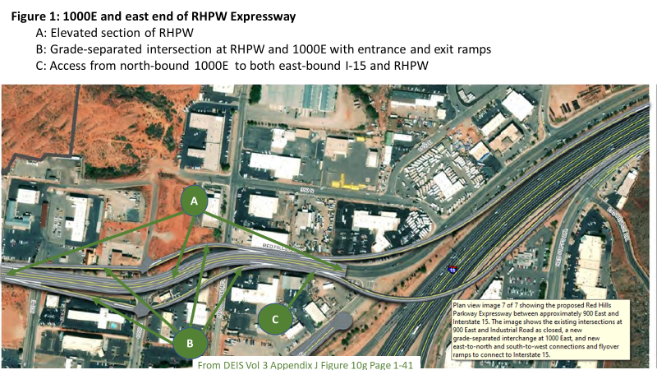

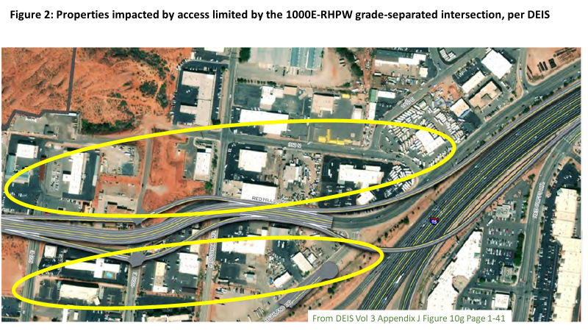

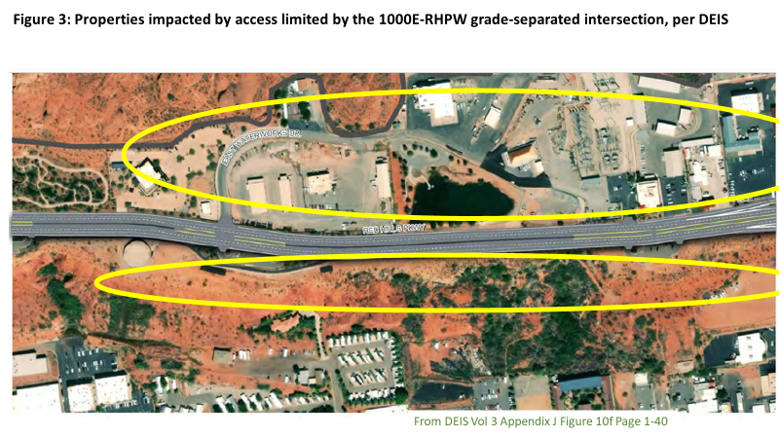

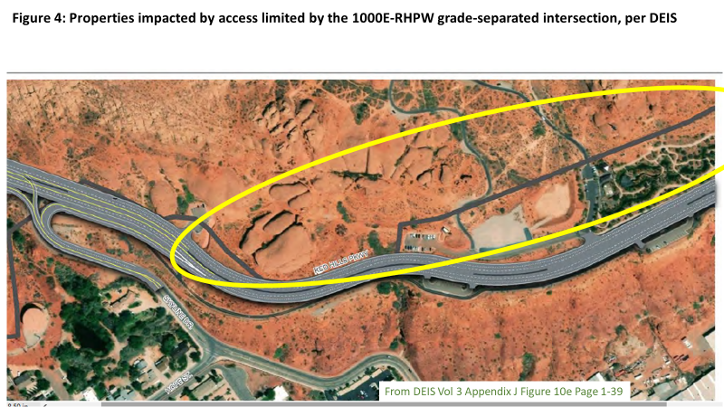

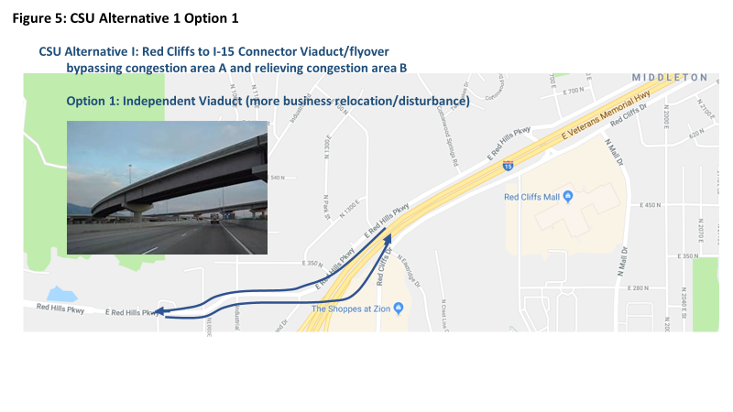

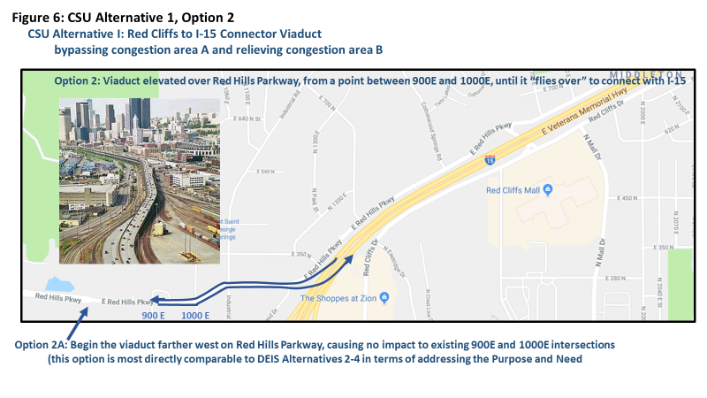

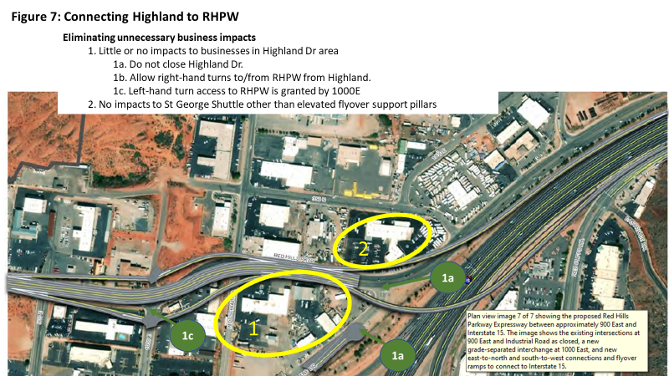

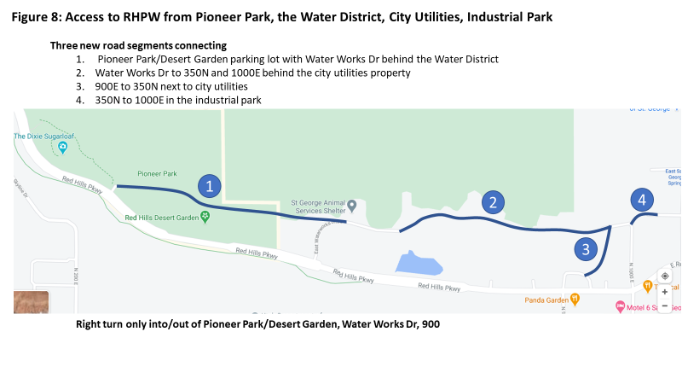

Table 1: Accounting of DEIS Alternative 5 Impacted Properties

Analysis of DEIS Alt. 5 Business Impacts
Parcel ID or Owner | Parcel Type: | Owner Name | Size- Acres | Purchase - Acres | Map Label (next page) | CSU's Guess of the Reason for DEIS’s stated Impact | CSU’s Suggested Solutions
Relocations
SG-1328-A-1-N | C | Panda Garden Take Out | 0.7 | 0.7 | A | A. Ramps for 1000E - RHPW intersection in DEIS Alternative 5 | Since the reason for this impact is not applicable to the DEIS purpose and need, it should not be counted. Even if St George decides it wants to create this intersection improvement independently, this property does not need to be impacted at all.
SG-1328-A-2-N | C | Motel 6 | 1.2 | 1.2 | B | B. Ramps for 1000E - RHPW intersection  And/or  Flyover ramp for CSU Alternative 1 Option 1 | Since the reason for 1000E intersection’s impact is not applicable to the DEIS purpose and need, it should not be counted. Even if St George decides it wants to create this intersection improvement independently, this property may not need to be totally purchased and relocated.  If CSU’s alternative 1 option 1 is implemented, there would be some impacts for support pillars, but not total relocation. Option 2 would have not impact.
SG-1328-A-3-N | C | Studio 6 | 1.5 | 1.5 | C | Same as A above | Same as A above.
SG-1381-B | C | The Marble Factory | 2.1 | 2.1 | D | D. Access to RHPW limited by 1000E-RHPW intersection | D. Since the reason for this impact is not applicable to the DEIS purpose and need, it should not be counted. Even if St George decides it wants to create this intersection improvement independently, this property does not need to be impacted at all since access can be gained by via Highland, which does not need to be dead-ended short of RHPW.
 |  | Ridgeline Financial of Utah |  |  | E | Same as D above. | Same as D above.
SG-1381-D | C | Tropical Smoothie | 0.9 | 0.9 | F | Same as B above | Same as B above
 |  | Stars Dance Studio |  |  | G | Same as B above | Same as B above
SG-1381-N | C | Winsupply | 1.9 | 0.5 | H | Same as D above | Same as D above.
SG-1740-A-1-B-3-A | C | Beehive Rental and Sales | 0.7 | 0.3 | I | Same as D above. | Same as D above.
SG-IND-P-17-B | C | St. George Shuttle | 3.2 | 0.8 | J | Flyover ramp for DEIS Alternative 5 or CSU Alternative 1 and/or access limited by flyover | This should be minor impact only for flyover support pillars
SG-IND-P-18-B | C | Southwest Diesel | 1.8 | 0.3 | K | Access limited by flyover | Access need not be limited.
St. George Streets and Energy |  | City Utilities | 45.2 | 3.7 | L | L. Access to RHPW blocked by 1000E-RHPW intersection and DEIS Alternative 5 or CSU Alternative 1 Option 1 flyover connection | L. Access could be allowed via new connection from Waterworks Dr. to 350 N.
Partial Acquisitions
SG-1381-E-1 | C | Gustave A Larson Company | 3.5 | 0.8 | M | Same as L above. | Same as L above.
SG-1734-A-1-B-1 | C | St. George Animal Shelter | 5.5 | 0.1 | N | Same as L above. | Same as L above.
SG-1734-A-1-B-2 | C | AWI | 1 | 0.2 | O | Same as L above. | Could be same as L above if access could be granted to the new road.
SG-1740-A-1-B-1 | C | Beehive Rental and Sales | 0.3 | 0.2 | P | Same as L above. | P. No need to limit access to RHPW or Highland since flyover is elevated.
SG-1740-A-1-B-2-A | C | St. George V-Twin Motorcycles | 1.1 | 0.2 | Q | Same as L above. | Same as P above.
SG-IND-P-17-A | C | St. George Shuttle | 0.7 | 0.6 | R | Same as L above. | R. No need to limit access to RHPW since flyover is elevated
SG-IND-P-18-B | C | Southwest Diesel Service | 1.8 | 0.3 | S | Same as L above. | Same as R above.
Vacant Properties

SG-1337-A-2 | V |  | 1.7 | 0.1 | T | Widening of RHPW | No issue
SG-1734-A-3-A | V |  | 0.6 | 0.1 | U | Widening of RHPW | No issue
SG-1734-A-3-B-1 | V |  | 4.7 | 0.2 | V | Widening of RHPW and/or access to RHPW blocked | No issue on widening, but access would be solved by Water Works connection to 350N
Existing Roads
SG-1344 | R |  | 1.6 | 0.3 | W | Water Works left turn blocked | Access RHPW from connection to 350N
SG-1361-B-2-B | R |  | 2 | 0.3 | X | Unable to locate, unable to guess impact | TBD
SG-1363 | R |  | 26.9 | 1.8 | Y | Unable to locate, unable to guess impact | TBD
SG-1734-B | R |  | 0.9 | 0.2 | Z | Unable to locate, unable to guess impact | TBD
SG-5-2-20-2100 | R |  | 27.5 | 8.7 | AA | Unable to locate, unable to guess impact | TBD
 | R | St George | 0.1 | 0.1 | BB | Unable to locate, unable to guess impact | TBD
 |  | Totals | 139.1 | 26.2

Parcel Type:
C = Commercial
V = Vacant
R = Road

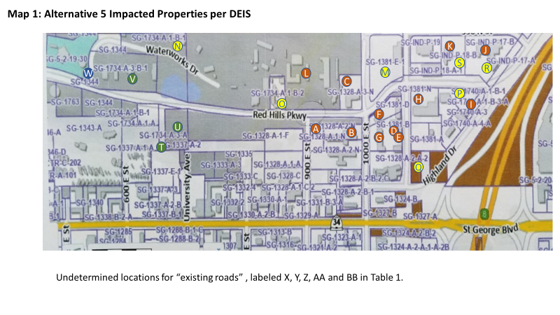

July 21, 2020 Public Meeting, starting at minute 33; subsequent pronouncements by local government officials.
DEIS Vol 2, table 1-5.2, page 1-7.
See Red Cliffs Coalition NCH DEIS Comments, section 2.1.1 (discussing preferred Northern Corridor Highway alternatives).
DEIS Vol 2 Section 3.26, Table 3.26.6, Alternative 5 Property Impacts, Page 3-168
A more complete comparison seems to be required per BLM Land Use Planning Handbook, page 161
Red Cliffs Coalition NCH DEIS Comments, section 2.1.1 on our preferred Northern Corridor Highway alternatives, beginning on page 15.
DEIS, Vol 1, section 1.2.1, ROW Applicant’s Objectives.
DEIS Alternative 5, Vol 3, Appendix J, section 4.8
“The Red Hills Parkway Expressway environmental analysis is based on a conceptual roadway design that assumes no additional ground disturbance outside the current fencing would be necessary.” DEIS Vol. 2, Pg. 3-57
DEIS Vol 2, Chapter 3 section 3.26 on Socio-economics, table 3.26-6, Alternative 5 impacts
Ibid
Based on DEIS Vol 2 Section 3.26, Table 3.26.6, Alternative 5 Property Impacts, Page 3-168, with highlighted columns added. See “Parcel Type” coding below.

