Background on the Northern Corridor Highway
In 2019, Washington County requested approval of the Northern Corridor Highway (NCH) through the protected Red Cliffs National Conservation Area (RCNCA, which overlays the Red Cliffs Desert Reserve) by applying for a right-of-way (ROW) under the National Environmental Policy Act (NEPA). The Bureau of Land Management (BLM) and the US Fish and Wildlife Service (FWS) are managing the process. This is the county’s latest of 7 attempts over the past 25 years:
- After the Mojave desert tortoise was listed as “threatened” under the Endangered Species Act, the county entered into a Habitat Conservation Plan (HCP), establishing the Red Cliffs Desert Reserve in 1995 as protected habitat and a relocation site to enable development throughout the county without having to go through separate environmental impacts studies for each property. The county tried unsuccessfully to get the Northern Corridor approved as part of the HCP.
- The county got our congressional delegation to add the approval of the Northern Corridor Highway (and the Lake Powell Pipeline) into a 2006 draft public lands bill. Local citizens objected, forming CSU (as Citizens for Dixie’s Future, at the time) as a grass roots organization to fight it. The result was section 1974 of the Omnibus Public Lands Management Act of 2009, forming the Red Cliffs National Conservation Area, overlaying the Reserve as additional protection, excluding the highway (and the LPP).
- The county attempted to authorize the highway during the Resource Management Plan development for the NCA in 2015. It failed, due to incapability with the purpose of the NCA.
- They appealed that decision to the Interior Department, as were also denied.
- Then they tried 2 bills in Congress in 2018, which failed.

This NEPA process has several steps after the initial application and determination that the project is of significance and scope to require an Environmental Impact Statement (EIS):
- “Scoping”, which is the process of determining what is to be included in the scope of studies related to the ROW, was completed early this year. About 20,000 letters were submitted by the public suggesting topics that should be in the scope. CSU (together with our Coalition partners) submitted 357 specific technical requests for topics to be included.
- The Draft EIS, covering all aspects of the requested highway ROW, even those not technically “environmental”, in response to scoping requests, was issued for public comment in June, with the comment period closing in early September. Over 15,000 comment letters were sent to the BLM. Huge numbers. CSU submitted 305 detailed, substantive comments on the shortcomings and errors in the Draft EIS. We also noted that only about 75% of our scoping requests were not addressed, with no explanation of why.
- BLM and FWS are now reviewing the comments, and plan a November 13th Final EIS.
- The public will have 30 days to protest the conclusions of the Final EIS, ending December 13th.
- The Record of Decision (ROD) is planned for January 13, just before the election results take effect.
- There are actions that can overturn or force a restart of the NEPA process, ranging from congressional action to a federal lawsuit.

Origins of Northern Corridor Highway Concept
The county has had the concept of a “ring road” around the metro area for a long time, probably since the early1990s. It’s hard to say this old concept makes sense for a relatively small metropolitan area, with very difficult terrain and large chunks of public lands with sensitive habitat and values beyond moving traffic. But this is Utah, where public lands are not seen as a benefit, where local governments mistakenly think they have the wherewithal to manage them.
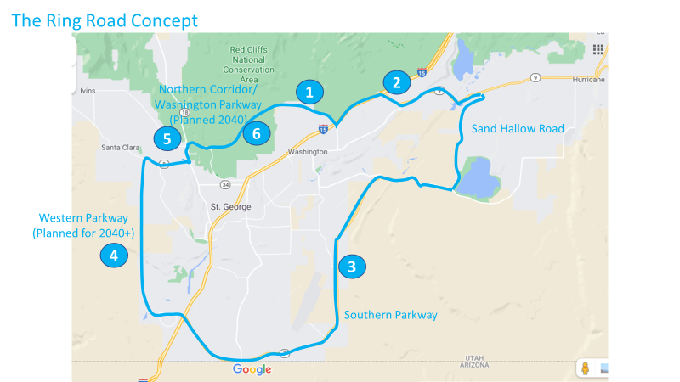

Going around the ring clockwise:
- The new Washington Parkway Extension from the top of Green Springs to I-15 exit 18 forms the first part of the northern segment of the ring.
- I-15 exit 18 to SR9 out to western Hurricane forms eastern part of the northern segment.
- The Southern Parkway and Sand Hallow Road form the south and east segments.
- The planned Western Parkway would form the western segment, if/when it’s completed.
- Sunset/SR8-Bluff/SR18–Red Hills Parkway form the western part of the northern segment.
- And the Northern Corridor Highway would form the central part of the northern portion, if it’s allowed.

Segment 4 is controversial for the traffic it will bring to Sun River and Bloomington.

The controversy over Segment 6, the Northern Corridor Highway, is centered on holding our elected officials to the promise they made to protect the Red Cliffs Desert Reserve/National Conservation Area, in exchange for enabling development throughout the county. They immediately plotted to bulldoze it, and encouraged indiscriminate development to crowd the very edge of the protected area, assuming they could break their agreement, making alternatives more difficult. It is for this segment that we have proposed several alternatives, two of which were analyzed in the recent Draft Environmental Impact Statement (DEIS), both of which were shown to be superior at handling traffic, with none of the environmental impacts, and with less cost. But our elected officials don’t like them.

